Database creation:
create database gym;
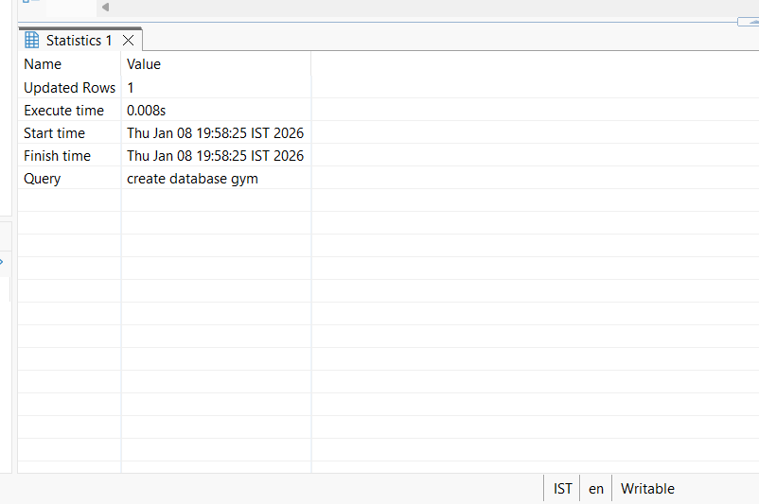

Table creation:
use gym;
create table entry(
Mem_id int,
Mem_name varchar(250),
Days_booked int,
Days_Workout int,
Hours_workout int);
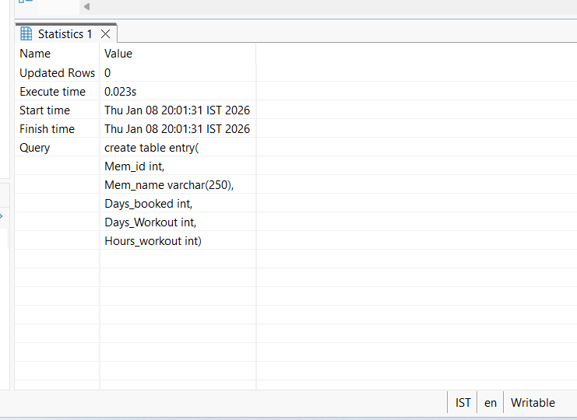

Table values insertion:
use gym;
insert into entry(Mem_id, Mem_name, Days_booked, Days_workout, Hours_workout)
values('2021', 'Ram', '30', '22', '22'),
('2022', 'Vijay', '30', '22', '22'),
('2023', 'Reena', '30', '22', '22'),
('2024', 'Hari', '30', '22', '22'),
('2025', 'Mark', '30', '22', '22'),
('2026', 'Sita', '30', '22', '22');

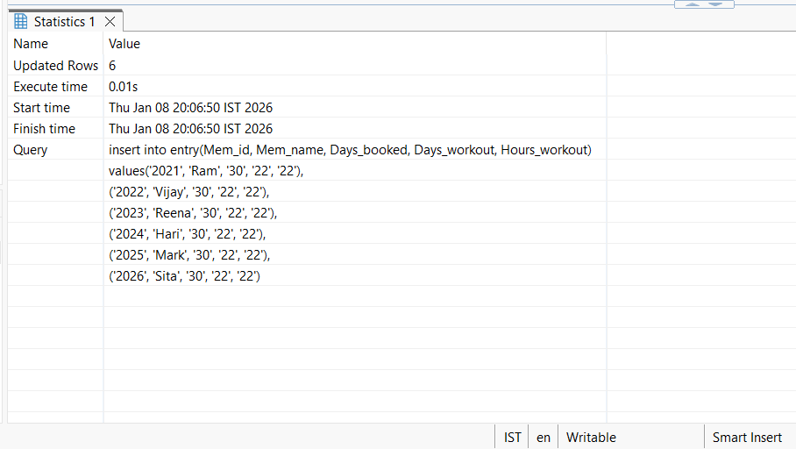

Select query:
use gym;
select * from entry;
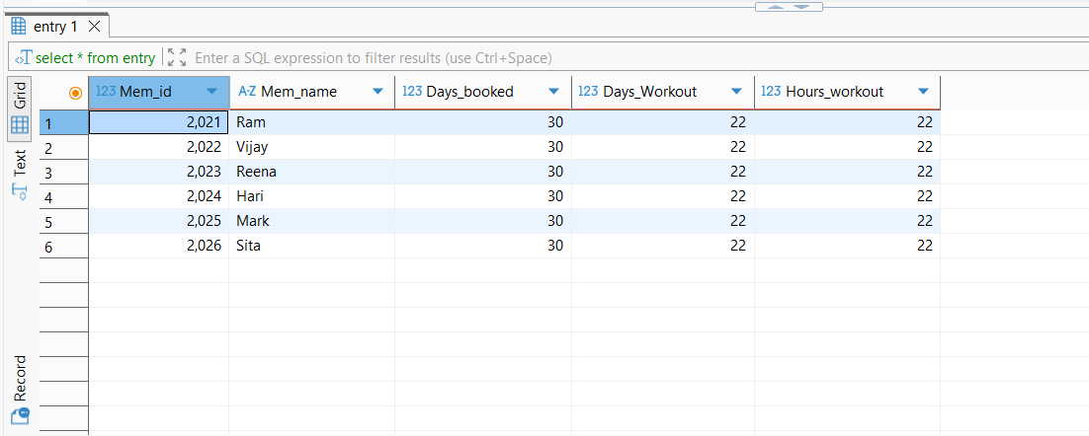

Select query with condition:
use gym;
update entry set Days_workout = 25 where Mem_id = '2022';
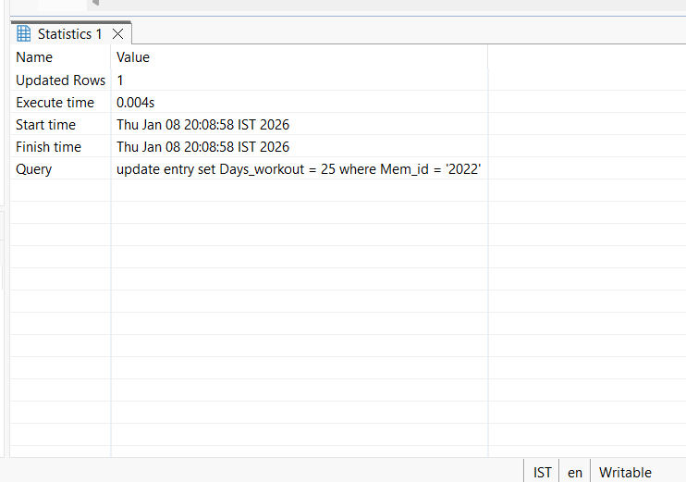
use gym;
select * from entry;
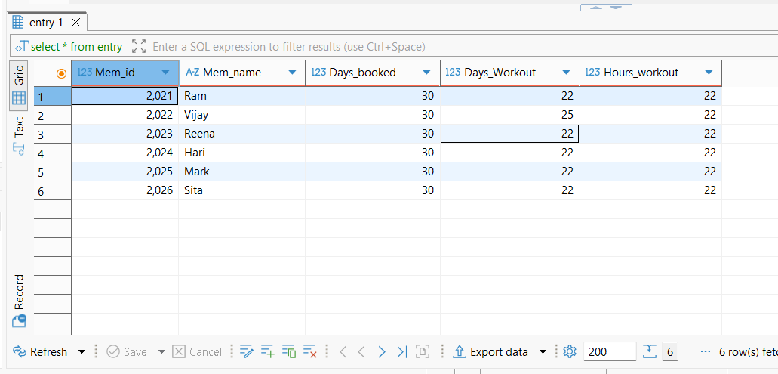

use gym;
select * from entry where Days_workout = '25';

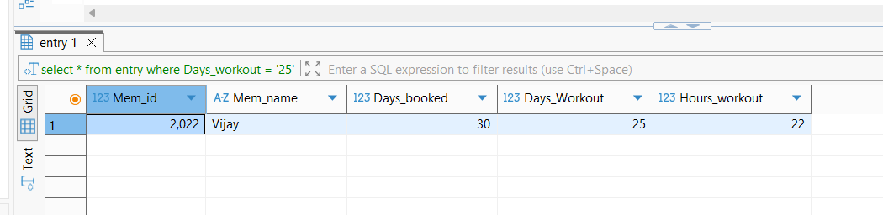

Delete query:
use gym;
delete from entry where Mem_id = '2024';
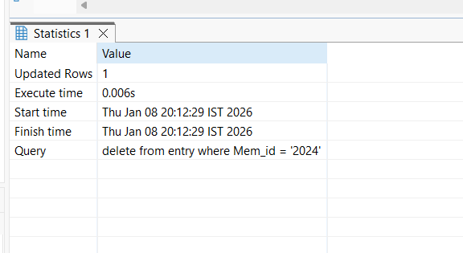

use gym;
select * from entry;

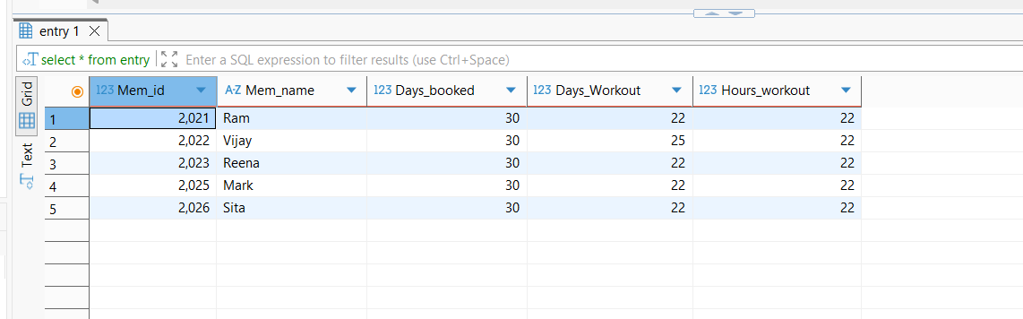

Truncate query:
use gym;
truncate table entry;

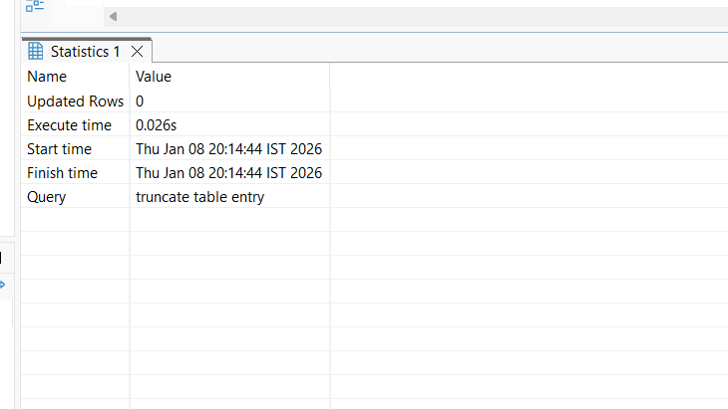

use gym;
select * from entry;

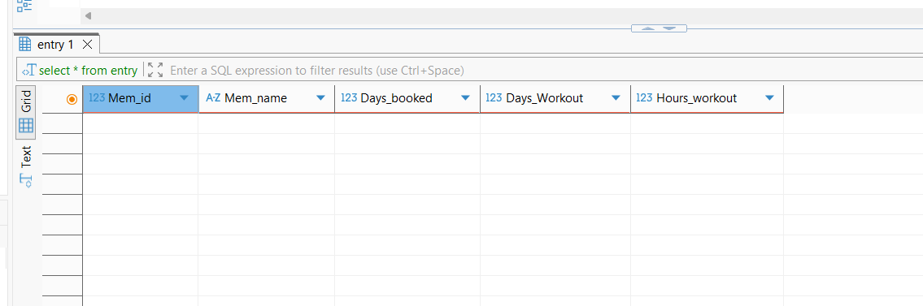

Drop query:
use gym;
drop table entry;

